Living Labs Program– Project Proposal for Faculty/Staffs & External Partners
Submit your proposal by January 16, 2026, and get the chance to be one of the other Living Labs teams that are transforming our beloved HKUST into a sustainable and smart campus. Once the Living Lab Committee has shortlisted the projects, the project teams will take part in our Living Lab pitch day to present their ideas. Following this event, the winners will be announced a few weeks later.
The project proposal should be detailed and shortlisted project teams may receive written feedback and/or a follow up consultation meeting.
Your Living Lab proposals should aim to address our University's 2028 Sustainability Challenge or Challenge Statements developed by our Swire Properties, Campus Management Office, and Campus Services Office.
Proposals must be submitted by January 16, 2026 to be eligible. You can reach us at ssc@ust.hk with further questions about the proposal process. More details can be found on our website.
Living Lab Application Milestones
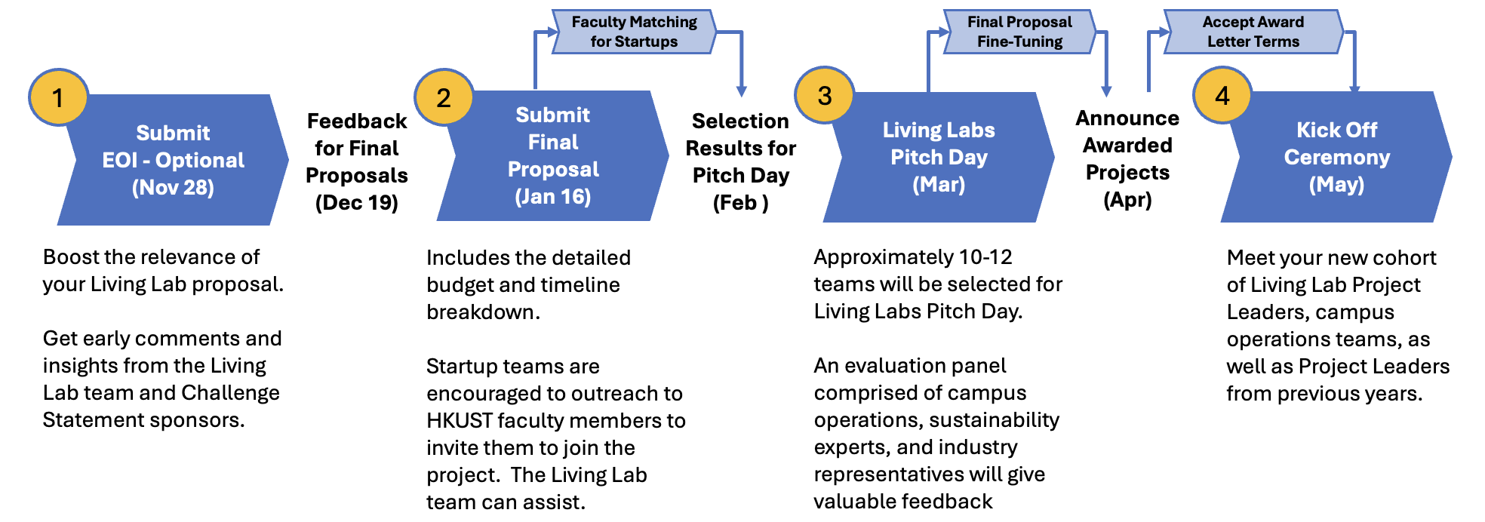
Sustainable Smart Campus as a Living Lab – Project Proposal
 | Remarks | Proposal
Project Name
Team Leader & Members | Provide the name(s) and affiliated unit(s) of your team and ensure all team members have given their consent to join the project.  We encourage an interdisciplinary team with diverse team expertise; please appoint at least one dedicated team leader.
Project Description | - What kind of challenges are you trying to solve? What specific problem are you addressing?  - What are the direct benefits to the campus?  - What are novel areas of research that could emerge from this Living Lab project i.e. what potential research papers could be published?
Stage of Development | - Please indicate your project’s current Technology Readiness Level (TRL)  - What stage of development is your project currently?  - What are the milestones you have achieved?  - Do you have any related projects outside of campus?
Visibility and Educational Potential | - How will your project engage and educate the campus community?  - What are the educational plans and timeline for outreach and knowledge sharing?  - Please explain how the project can be explained to the different segments within our community, especially if an outreach program is part of the project.
Sustainable and Smart | - Please explain how this project meets the definition of “Sustainable” and “Smart”
Project Timeline | - What key milestones will you achieve along the way?  - Which party is responsible for each milestone deliverable?
Budget Plan  - Line-level budget | Please identify  - Capital costs (equipment, supplies, materials)  - Staffing costs (full or part-time, non-student), please indicate the scope of work details. Maximum of $500k over two years.  - Student support (PG student, UG stipends, internships) NOTE: funding is not available for research postgraduates (RPg)  - Ongoing costs (costs for ongoing maintenance, repairs, subscriptions, or other recurring costs). Please include if these costs are part of this budget, or if other university unit will take over (e.g., CMO, ITSC).
- Non-Budget Resources | - Please include any resources needed that are outside the scope of the budget. Examples include the allocation of space in a building or landscape; technical expertise from university professional staff.
- RA Resources Support | - RAs working directly for the SSC can be “loaned” to project teams in support of project work, available for up to 25% of their time. If you are interested, please indicate the type of work needed, specialty skills requested, and what period(s) in the two-year cycle you will need assistance.
- Value for Money | - How does your project ensure cost-effectiveness? The breakdown of the budget of the project.  - What is the expected return on investment / potential economic value (e.g. payback time)?
Impact to Society | - What are the potential impacts to the wider community in terms of (ESG) economy, wellness and environment?  - How does the project positively influence the community outside the campus?  - Will the project have the potential to generate Intellectual Property?  - Is there potential for the project to apply for other funding and grants?
Project Conclusion | - Please explain how the project will end, and what happens at the end of the project lifespan.  - Consider things like whether the project budget covers the de-installation or removal of the equipment, or how the equipment can be safely and efficiently reused or recycled.

The Living Lab Program encourages HKUST Faculty and start up collaboration. Start-ups may submit a Living Lab project proposal that meet the following conditions:
- The project proposal meets specific goals and targets of the HKUST sustainability challenges;
- The startup establishes a collaboration with at least one HKUST faculty with matched expertise to jointly develop the project proposal;
- In the case where foreground Intellectual Property is generated from the project, IP ownership is determined based on the inventive contributions of the start up and HKUST faculty, in accordance with the University’s IP policy. If the patent is approved to be filed, the University will cover the patent application fee based on the inventive contribution of the HKUST faculty. The procedures of invention disclosure can be found at https://okt.hkust.edu.hk/working-with-okt-on-patent-application

SSC Project Criteria Rubrics (for Proposal Development Guidance)
Criteria | Unsatisfactory | Improvement Needed | Satisfactory | Exceptional
Challenge Statement  (20%) | Projects that cannot address the challenge statement and provide a clear or specific response to the problem identified in the challenge statement. | Project partially addresses the challenge statement, but there are gaps or areas that could be improved and need fully explain its approach. | Project provides a clear and specific response to the problem identified and how it will address the importance or significance of the problem outlined in the challenge statement. | The project provides a clear, specific, and compelling response to the problem identified in the challenge statement and powerfully articulates how it will address the critical importance and significance of the problem.
Stage of development  (10%) | Requests for seed grant, basic research, entrepreneurship. | Project ideas with reasonable opportunity for campus but lack definition or concrete steps for implementation. | Idea is further developed with a general budget, rough outline, and implementation timeline. Shared idea with campus operations staff (CMO, etc). A demonstrable prototype or pilot has been developed. | Idea has well-defined project scope of work, line-level budget, timeline, and locations for implementation. Incorporated feedback from campus operations staff (CMO, etc). A demonstrable prototype or pilot has been developed.
Visibility and Educational Potential  (20%) | Projects with zero potential for broad educational outcomes for the community; or no potential for follow-on research or knowledge transfer. | Projects that appeal only to people who specialize in the field; limited ability to showcase the technology or approach. Some data or information generated with potential for follow-on work. | Internal or external projects that appeal to more than one stakeholder group, with some visible learning opportunities identified. Identification of KPIs and data potential for future follow-on projects. | “Home-grown” projects that are designed to engage multiple stakeholder groups and have potential for high visibility within the campus. Identification of KPIs and data potential for future follow-on projects, with specifics carved-out for student hands-on projects like UROP/USEL or service-learning experiences.
Sustainable and Smart  (15%) | Projects that cannot satisfy definitions. | Projects that have marginal smart or sustainable benefits, but not combined. | Projects that can demonstrate positive sustainable and smart elements. | Projects that satisfy the definitions in ways that provide a clear demonstration of how the approach is a model for the vision, and would be a clear source of inspiration and pride for the HKUST community.
Value for money  (15%) | Projects that cannot demonstrate a positive value for money proposition; top heavy with staffing costs. | Value for money and cost benefit analysis included, but weak. Too much heavily weighted on staffing expenses. | Positive value for money in life-cycle CBA, clearly defined end-of-life strategy (plan for hand-over). Staffing expenses are reasonable and justifiable. | Positive value for money in life-cycle CBA, clearly defined end-of-life strategy with salvage / recycling plan; clear and accepted roles for admin staff for hand-over. Staffing expenses are reasonable and justifiable.
Potential Impact to the society (20%) | Projects (1) fail to define key performance indicators (KPI) and (2) demonstrate little or no potential positive impact on the mentioned areas. | Projects with (1) ill-defined key performance indicators (KPI) and (2) limited and weak potential positive impacts on the mentioned areas. | The project (1) develops clear and relevant key performance indictors (KPI) and (2) demonstrates clear and strong potential for positive impacts on the mentioned areas. | The project (1) sets well-defined key performance indicators (KPI) to measure project success and (2) demonstrates exceptional and very strong potential positive impact on the mentioned areas.
Market Potential (Bonus) | The project does not demonstrate any clear market potential or commercialization opportunities. | The project demonstrates limited market potential or commercialization opportunities. | The project demonstrates clear market potential and viable commercialization opportunities. | The project demonstrated strong market potential and a clear pathway for scaling up.

